# Binaya Rimal

# 12/08/2023

**Module 7**

# CS 255 System Design Document Template

## UML Diagrams

### UML Activity Diagrams

### UML Sequence Diagram

**Reservation Workflow Sequence Diagram**

### UML Class Diagram

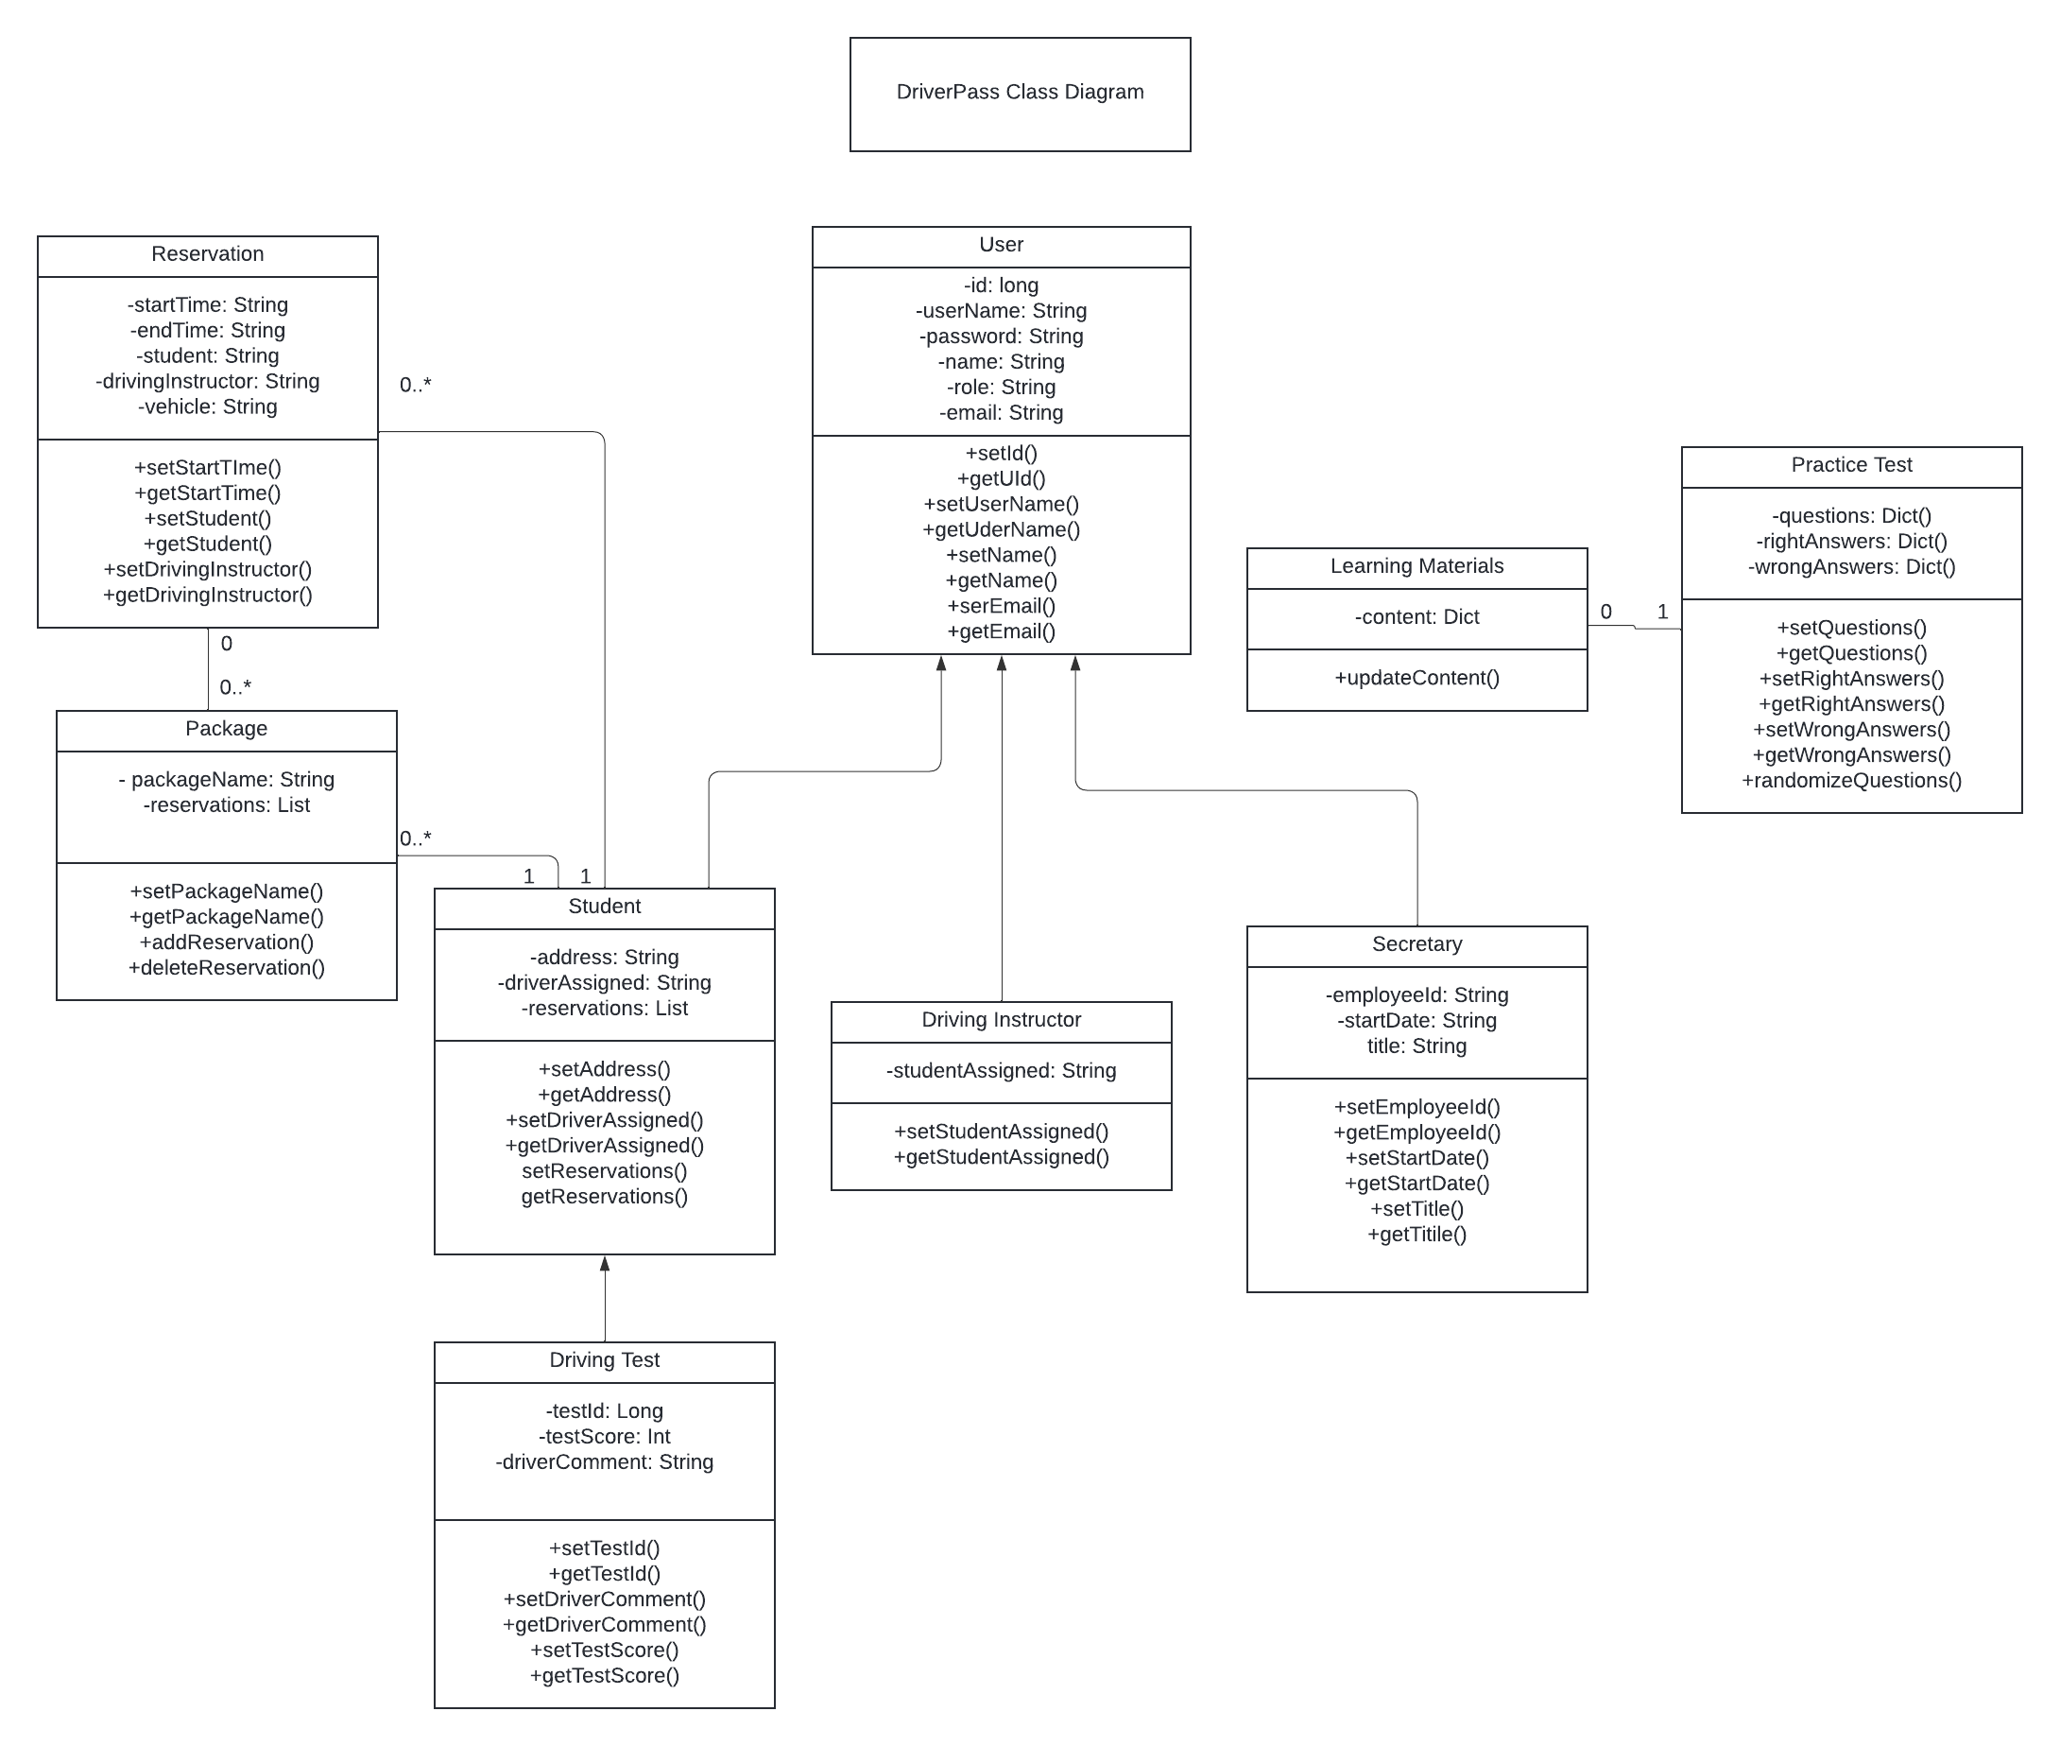

## Technical Requirements

*[Based on the diagrams you have created, describe the technical requirements of your system. These requirements should address the required hardware, software, tools, and infrastructure necessary for your system design.]*

* Set up cloud environment from Azure or AWS.
* Set up a Relational Database.
* Use OAuth to facilitate authorization workflow.
* Implement REST API to interact with database.
* Use 3rd party scheduling tool for reservation system.
* Implement Analytic tools to analyze user activities.
* Use HTTPS encryption protocols for secure data movements.
* Data protection methos must meet standards for data protection regulations, e.g., HIPAA.
* Implement API from the DMV to get updates on learning materials.
* Consider phone, tablet, and desktop for UI/UX design.
* App should be compatible with Windows, IOS, Mac, and Android operating system.